**Laying it all out on the table**

**Sharing on social media**

Sharing the messages your community writes on your tablecloth on social media is a great way to spread the word and get a wider group of people to engage with the activity.

To help you share them across your channels, we’ve pulled together some content ideas and top tips.

As each of your tablecloths will be unique, we’ve provided ideas for how you could adapt and share yours in your own way on Instagram, Facebook and X (formerly Twitter).

Please do tag the Trussell Trust (@TrussellTrust) and JRF (@jrf_uk) into your content, and we can share and amplify your content!

**Content ideas**

**Facebook**

* Create a video of someone talking about what you’re seeing in your community right now and any stories about people you’ve helped recently (just make sure you have consent to share this).
* Record a 30 second video of some of the messages on your tablecloth. You could make this video even better by getting someone at your food bank to read them out as you record!
* Share photos of messages on your tablecloths. You could engage your audiences by asking them what they would write on your tablecloth in the comments.
* Share a photo of some of your staff members and volunteers holding up your tablecloth.

**Quick tips for posting to Facebook:**

* Posting videos? Keep videos as short as possible, 30 seconds is ideal.
* When writing copy, keep it short and put line breaks between paragraphs.
* Make sure your post is accessible by adding alt text to graphics and photos, and subtitles to videos.
* Upload content in the right formats: that’s square for graphics and videos on Facebook.

**Instagram**

* Are you hosting any events to get members of the public to come down and sign your tablecloth? Create a simple graphic in Canva with the time and date of your event on! Add this to Instagram stories, and add a link sticker to the post so people can click the link and sign up.
* Film someone at your food bank reading out 3-4 of the most emotional or inspirational messages on your tablecloth and turn this into a reel for Instagram.
* Want to get something out quickly? Take some photos of different messages on your tablecloth and upload them in a carousel to Instagram. Please remember our election guidance and ensure these messages aren’t party political.
* Create a video of someone talking about what you’re seeing in your community right now and any stories about people you’ve helped recently (just make sure you have consent to share this).
* If you’re hosting an event, you could upload live Instagram stories of your event, showing what you’ve been doing, people signing the tablecloth and short video clips of people at your food bank talking about why an Essentials Guarantee is needed.
* If you feel like pushing the boat out, you could capture some vox pops of members of the public. You could ask them for their reactions to the fact that Universal Credit is only £91 a week for a single adult, or why they felt compelled to write on your tablecloth. Just make sure you get consent of anyone involved in this.

**Quick tips for posting to Instagram**

* Creating reels (short videos on Instagram)? You can quickly and easily edit reels in the Instagram app. Make sure that you add subtitles to any videos you create as a lot of people watch videos without sound (you can do this using the captions sticker).
* Best practice is to keep reels as short as possible, under 30 seconds is ideal. Max length for reels is 90 seconds.
* You cannot add links in copy on Instagram, so make sure you add any links to your bio and say in copy ‘Follow the link in our bio’. You can add links to Instagram stories using the link sticker!
* Create content in the right formats for the channel: for videos, that’s vertical. For graphics that’s square. For Instagram stories, everything will need to be created in vertical formats.
* Uploading videos to Instagram stories? Don’t forget they can only be 60 seconds long.
* When writing copy, keep it short and put line breaks between paragraphs.
* Make sure your post is accessible by adding an image description at the bottom of your post copy. This is just simple text which describes what’s in your image.
* Make sure your videos are accessible by adding subtitles. You can add them easily in the Instagram app using the captions sticker.

**X (formerly Twitter)**

* Create a video of someone talking about what you’re seeing in your community right now and any stories about people you’ve helped recently (just make sure you have consent to share this).
* Share photos of messages on your tablecloths. You could engage your audiences by asking them what they would write in the comments.
* Are you hosting any events to get members of the public to come down and sign your tablecloth? Create a simple graphic in Canva with the time and date of your event on!
* Share a short 30 second video of some of the messages on your tablecloth.

**Quick tips for posting to X:**

* Keep copy short – you only have 280 characters to play with (and links take up 20 characters).
* Emojis are a great way to make posts more engaging, but use them sparingly. A good rule of thumb for X is to use 2.
* Posting videos? Keep videos as short as possible, 30 seconds is ideal, and 2 minutes and 20 seconds is the max length.
* Make sure your post is accessible by adding alt text to graphics and photos, and subtitles to videos.
* Upload content in the right formats: that’s square for graphics and videos on X.

**Tips with creating content**

**Tips for filming videos for social media**

* Film in portrait - hold your phone up vertically, not horizontally (landscape).
* If you are filming someone else, frame them in the centre. Like this:

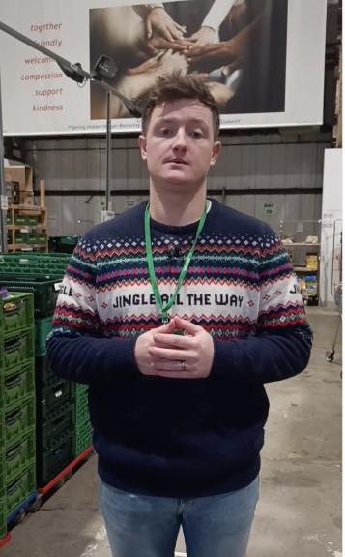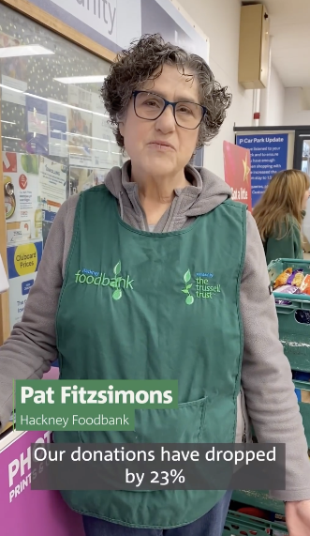

* If you are filming yourself, try not to zoom in too close to your face. Put your phone on a stable surface (like a table) or if you have a tripod, use that. You could also ask a colleague/friend to film you. You can use the front facing camera, though try to use the forward facing one where possible as this is higher quality.
* Check the lighting - film in a location with natural lighting.
* Check the sound​ – film in a quiet location with no background noise. If you have a clip-on mic available, please do use these.
* Film on a phone (it’s often better than a camera for social media!)​
* Keep answers short and snappy – try to keep answers to roughly 30 seconds and no longer than 60 seconds.
* Always speak from *your* perspective. How is the social security system affecting you, or people in your community? Don’t be afraid to let your personality show. Please note, if you are sharing any stories about people you’ve helped/come into contact with, make sure you have their permission before sharing anything.
* For any videos you create, make sure you add subtitles. This will help make your post accessible to everyone! You can add subtitles to your videos on Instagram using the captions sticker in the app, or you could download a subtitling app like Veed or CapCut.

**Consent**

If you are filming or taking photos of members of the public or sharing their stories, you will need to get consent from them. Please follow the consent processes [outlined here](https://www.trusselltrust.org/laying-it-all-out-on-the-table/).

**Engaging with comments**

Sharing stories on social media can sometimes encourage people to share their own stories back. Though this is powerful, we need to protect the people sharing their experience and ensure they’re signposted to support if they need it.

Here’s a few tips for doing this:

* If people share that they are struggling or need help when you post about the tablecloths, try to go back to them and let them know support is available. The process for this might differ due to processes at your food bank – but it could be something like: *Hi [insert name], we’re sorry to hear that you are struggling. 💚 If you need emergency support, please contact us on [insert contact lines] or you can call the free Help Through Hardship helpline 👉 https://www.trusselltrust.org/get-help/*
* If people share their own story of hardship off the back of seeing your posts, you could reply to these to acknowledge their post (as it can take guts to share personal experiences online). You could say something like: *Hi [insert name], thank you for sharing your story [and then relate to something they’ve said so they feel heard – ie saying we’re glad you were able to get the help that you needed]*
* If you spot any nasty or unkind comments back from other social media users to the person who has shared their story, make sure you deal with these quickly by hiding the comment or deleting if it’s bad, as well as banning the user.
* If anyone leaves any comments endorsing or criticising a particular political party, we advise leaving these.

If you have any more questions, you can reach out to the Trussell Trust’s social media team on [socialmedia@trusselltrust.org](mailto:socialmedia@trusselltrust.org)!