Community Organising and Campaigning end of year summary
20/12/2024

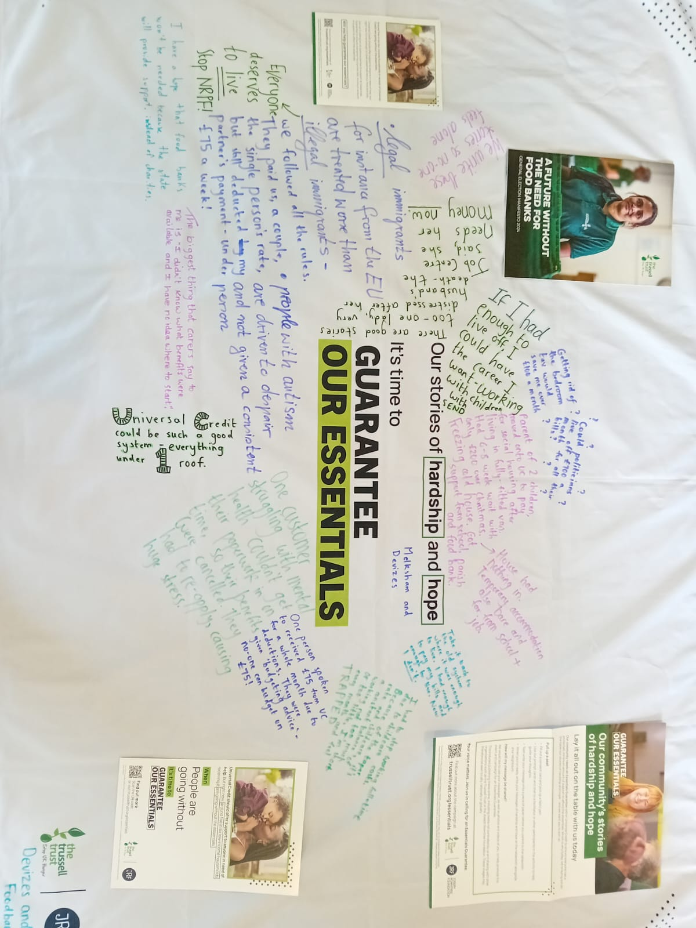
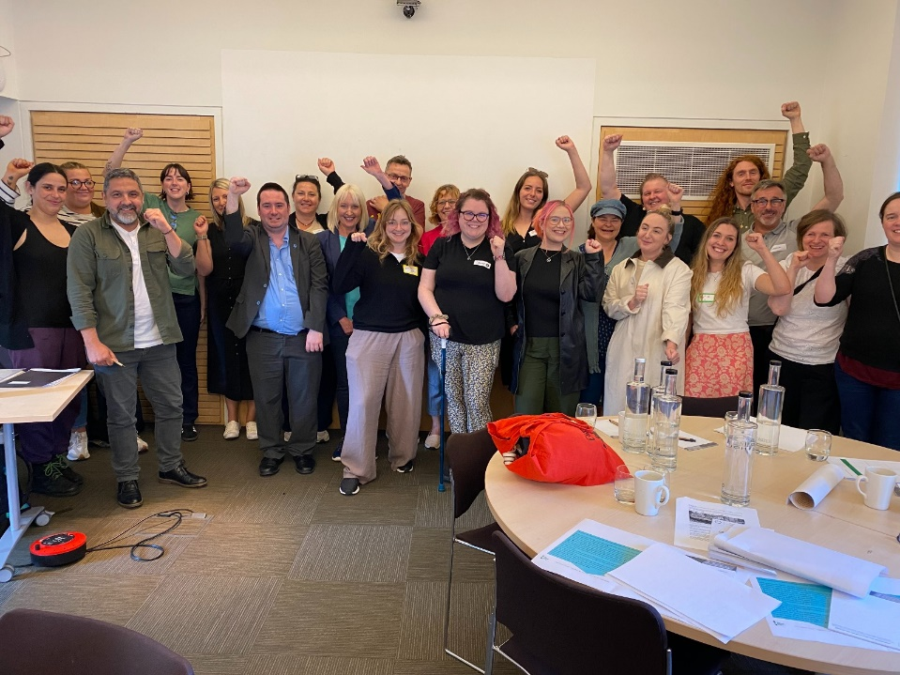
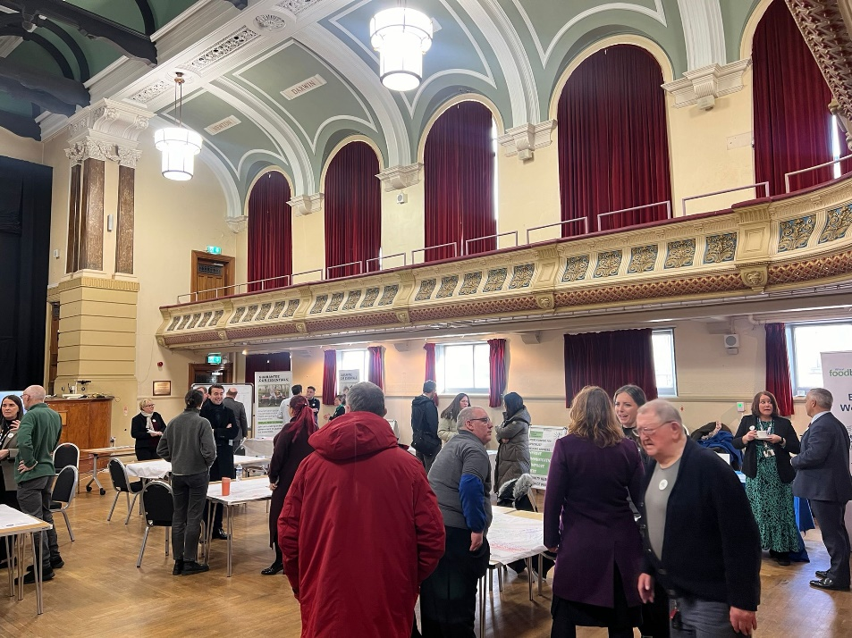
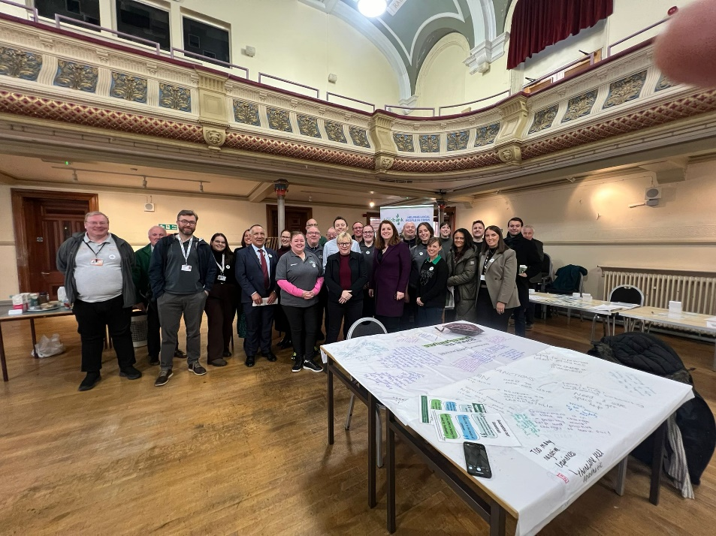

Summary of 2024

Wirral Community Foodbank Campaigners group
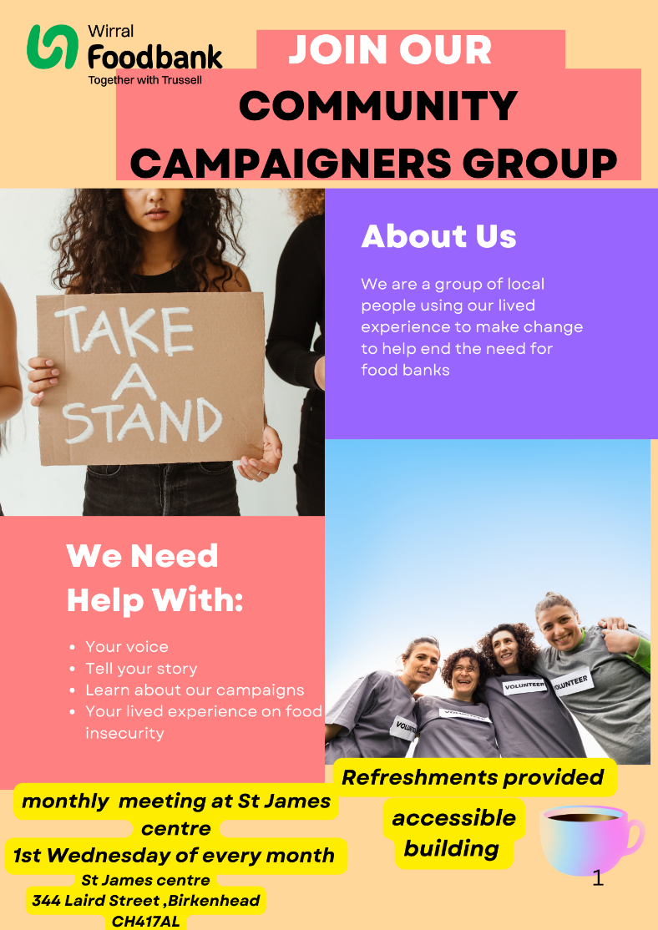
- We have an established campaigning team who meet three times per month to get organised, give input and plan our campaigning activities.
- Our aim is to end the need for foodbanks.
- We have been meeting since July 2024.
- Currently, we have a team 5-10 campaigners who are engaged in campaigning. This includes at present, a solid group of 5 who are able to regularly commit to activities and meetings. Some of the team have been taking on responsibilities such as co-chairing and
- The majority of people in the group have had their own experience of using the foodbank and of severe financial hardship and are passionate about making changes in their local community as well as on a national level.
- For anyone who would like to get involved, then we encourage you to attend one of our monthly get togethers at St James Centre in North Birkenhead. We meet every first Wednesday of the month from 11:00-13:00
- We are one of 50+ local groups who are organizing and campaigning for the end for the need for foodbanks across the UK. You can see an example of this in Liverpool here: https://www.feedingliverpool.org/campaigns/

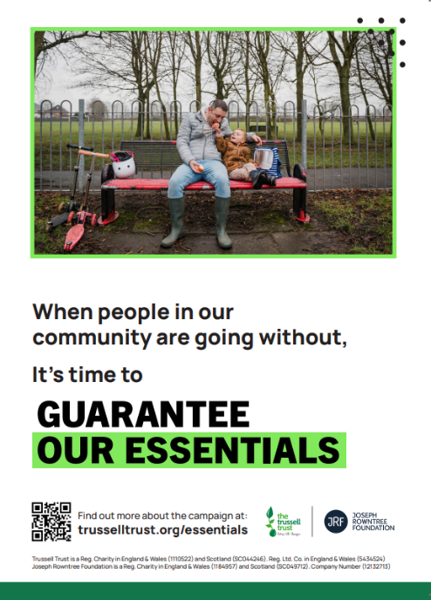
Guarantee our Essentials Campaign
The basic rate of Universal Credit should at least cover the cost of essentials like food, household bills and travel, but it is not currently set according to any objective assessment of what people need.
This is only £91 a week for a single adult. That means there’s a significant shortfall between people’s living costs and their income, and it’s pushing people to food banks. The majority of universal credit claimants are living in a negative budget and this is bringing a significant amount of people to the foodbank.
We are campaigning for the government to put in place a measure whereby Universal Credit is always aligned with the actual cost of living and to ensure that it never falls below that amount.
Numerous charities and community groups across the UK are also campaigning for an Essentials Guarantee for Universal Credit including Trussel, see more here Guarantee Our Essentials | Trussell
What have we been doing?
We have collected stories from people using our foodbank. These stories were used by Trussel to produce the 'Hardship Times' newspaper which was used for a national campaigning event held in Westminster to target MPs about the high level of foodbank usage and the need for an essentials guarantee with universal credit. You can access a digital version of the newspaper here: Stories of hope and hardship delivered to Westminster | Trussell
We have been communicating with our MPs and held a local campaign event to lobby MPs at Birkenhead Townhall. We ran a campaign stall which highlighted how much average essential costs are compared to rate of universal credit.
One campaigner held an event at her church to discuss the campaign and has been down in parliament with Trussel to speak with MPs about the campaign.

What can you do?
You can write to your MP about the need for an essentials guarantee with universal credit. Contact communityorgansier@wirralfoodbank.org.uk for more information on this.
You can share the hardship times newspaper Stories of hope and hardship delivered to Westminster | Trussell or contact communityorganiser@wirralfoodbank.org.uk to order more paper copies.

More face to face advice and support on money matters
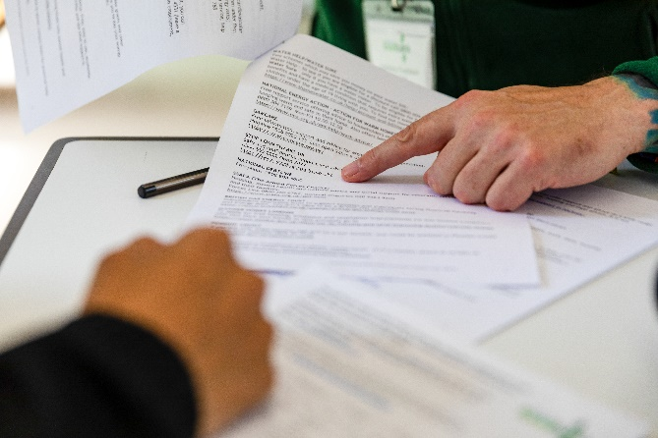
This is our local campaign that we have started running in 2024 and is aimed at making
We chose this campaign based on the stories we collected from people using our foodbanks, data from foodbank+ and discussions with the campaigners group.
We have decided to campaign locally for more face to face advice and support on money matters as we want people to access advice and support on debts, filling in forms, confusing bills, navigating universal credit etc, to ensure that people are in better financial positions.

- Issues related to benefits is one of the biggest drivers towards the foodbanks both locally and nationally. Trussel state that the 'design and delivery of the social security system' is the biggest driver towards foodbanks in the UK.
- Therefore, we believe that through improving access to advice and support on these issues, less people will be needing to depend on the foodbank as they will be in a better financial position.
- It is widely recognized that by having easy access to advice on these money matters, is one of several building blocks to having a society without the need for foodbanks. Many local organisations we have engaged with support this campaign and are working us.

- Our objectives for this campaign are as follows:
- Improving communications to improve access to advice
- More funding for these advice services
- For these services to exist in community hubs in a face to face settings.

- We are working with local advice organisations such as Citizens Advice Wirral, Wirral Change, Involve NW, Age UK and Mencap.
- We are working with Wirral Council and Magenta to improve communications.
- We are creating a unified information document/guide about accessing advice/ getting help locally.
- We have began discussions with Wirral Council regarding setting up a community advice hub in central Birkenhead.

Events
- Feeing Wirral event- We managed to use stories from people using our foodbanks to facilitate an activity around solutions for ending food insecurity with local professionals and volunteers who support people in these situations. These solution ideas were used by Feeding Britain in a report to government ministers.

- Birkenhead Townhall campaigning event – We ran our own campaigning event at Birkenhead Townhall to share the stories of people who had used foodbanks and to bring to life our campaigns to people within positions of power in the Wirral. Three MPs attended, the leader and CEO of Wirral council and members of the council’s public health team. We informed people of what changes can be made to decrease the levels of food insecurity. Following this event, we were invited to meetings with the local council to progress our local campaign objectives. We will continue to communicate and lobby MPs for their support to our campaigns.

Visions for 2025
- We will hold an open monthly meeting at St James Centre for anyone who wishes to get involved in campaigning. Expand our campaigning team.
- To continue our bi-monthly meetings at Birkenhead Fire Station and to develop the skills and responsibilities of current group members, i.e campaign lead, chair, secretary etc.
- Fleshing out our campaign strategy to ensure that we are following a sound method to achieve our campaign goals.

- To create and distribute an information sheet on how to access advice services and what they can help you with. To run stalls and speak to the general public in targeted areas about accessing advice and support on money matters.
- To set up a central community advice hub in Birkenhead – the highest area of foodbank need in Wirral. To create a welcoming open environment whereby people can access information, advice and support on debts, universal credit, PIP forms etc.

- Attend Trussel’s Lobby Day in June 2025 at Westminster to lobby MPs about Guarantee our Essentials campaign.
- Communicate regularly with MPs about our campaigns and what they can do to support.

- To involve the local press with our campaigns and improve our communication and media presence.
- Continue to run tablecloth activities at foodbank sessions to gather stories and listen to people who are using our foodbanks to ensure that we are getting our campaigns right and their stories shared.

Thank you to those who have supported us so far. We look forwards to making change in 2025!
For any further information or questions please contact our Community Organiser and Campaign Manager Beth Saunders via communityorganiser@wirralfoodbank.org.uk
Check out our webpage and access more in-depth articles about our work: https://wirral.foodbank.org.uk/about/campaigning/

