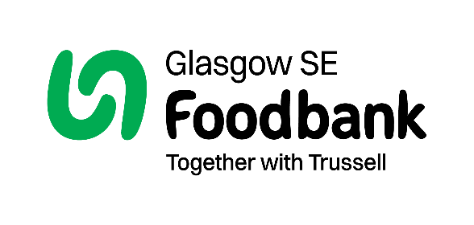

Complaints: Policy and Procedure

Policy statement

Glasgow SE Foodbank is committed to working in an open and accountable way that secures the trust and respect of stakeholders, and as such recognises the role of an effective complaints policy in fostering transparency, fairness, and a culture of continuous improvement.

Philosophy

Glasgow SE Foodbank undertakes to ensure that:
- Making a complaint is as straightforward as possible.
- Complaints are dealt with promptly, courteously, and discreetly – confidentially when appropriate.
- We will respond decisively with an explanation; an apology where we have been at fault; or provide information on the outcome.
- We will learn from complaints and use them to make improvements in the way we work.

We hope that the majority of complaints can be dealt with informally, addressed and resolved at the time they are made.

We will deal with your complaint as follows:
If you are unhappy about the Foodbank’s action, lack of action, or the standard of service we provide, please speak in the first instance with one of the volunteers or staff members who will seek to resolve the situation there and then.

If you remain dissatisfied with our response and wish to make a formal complaint, please submit the complaint:

In writing, addressed to The Manager, Glasgow SE Foodbank, Unit 1, Govanhill Workspace / 69 Dixon Road, Govanhill, Glasgow G42 8AT
- Or email our manager - denise@glasgowse.foodbank.org.uk
- Please write ‘complaint’ in the subject line.
- Include a full explanation of the problem, where, and when (date, time and location) it occurred, were there any witnesses and the effect this had on you.
- It would be helpful if you could describe what you think we should do to put things right.

1. We will acknowledge your complaint within five working days of receipt.
2. The person responsible for the investigation will write to you with their findings and proposed resolution, within twenty days from receipt of the complaint.
3. If the complaint is particularly complex, we will keep you informed of the investigation’s progress and if possible, the expected date of completion.
4. If you are dissatisfied with the outcome of the investigation you may appeal. Letters of appeal must be received within twenty-one days of the ‘outcome’ letter. Details of the person to whom you can appeal will be included in the outcome letter.
4. The complaint will be reinvestigated. You will be informed of the outcome within 10 working days.

If you make a complaint anonymously or do not provide contact details, will be unable to advise you of the outcome of the investigation.

Where complaints about staff behaviour or attitude are dealt with under Glasgow SE Foodbank’s disciplinary procedure, we will not able to advise you of the action taken, as such information is confidential.

If your complaint contains abusive or offensive language, then we reserve the right not to respond and to report any such communication to the Police.

Data Privacy Statement
We collate and analyse data about complaints so that we can improve the services we provide. We will collect personal information including your name and contact details, including postal address, telephone number, email address and social media contact information, in order to be able to communicate with you in relation to your complaint. We will also collect sufficient information about the situation that you are contacting us about, in order to understand what has happened. We may need to request further information depending on the nature of your complaint. We have a legitimate interest in holding this information in order to be able to monitor and improve our services.
Information gathered is accessed by Glasgow SE Foodbank employees and may be shared with advice agencies or professional services firms only if deemed appropriate.
(for example if your complaint relates to safeguarding we may seek guidance as to next steps. Where a complaint involves a food bank in our network, we may need to share this information with that food bank in order to understand what has happened and determine a resolution).
We keep this information for 2 years after your complaint has been closed, unless we have a requirement to keep it longer, in which case we will inform you of this. After this time the data will be aggregated and anonymised.

