
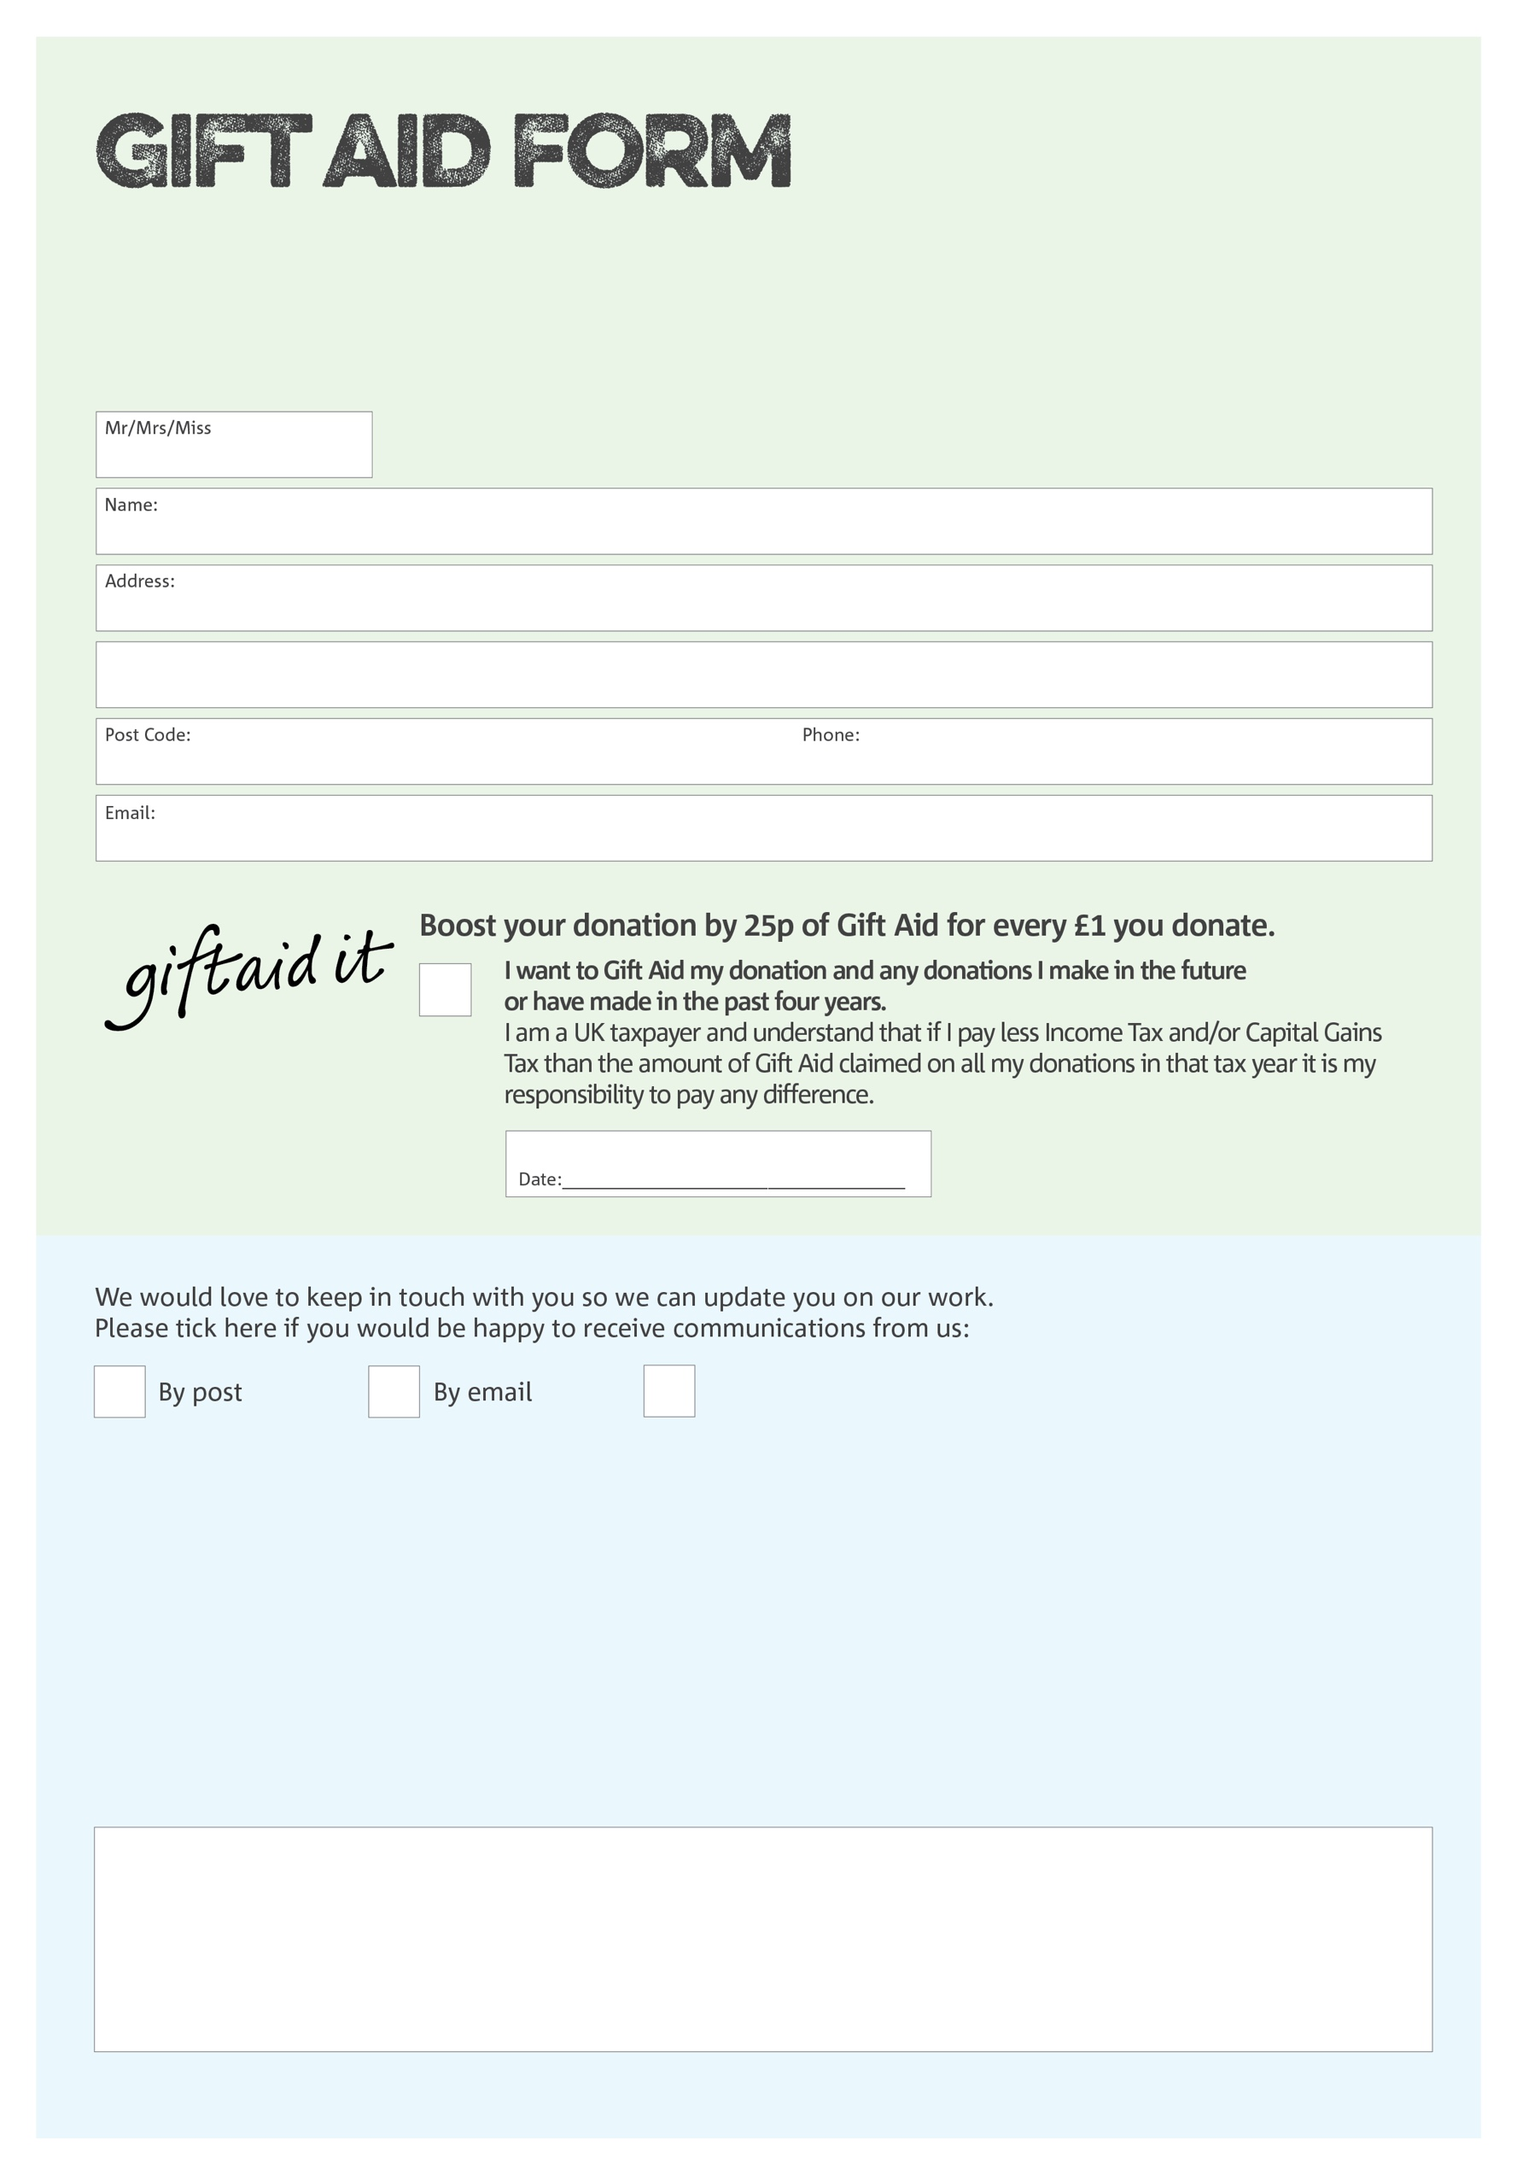
By filling in this form Lambeth & Croydon Foodbank will receive an extra 25p for every £1 you give at no extra cost to you. Thank you!

Data protection

Lambeth & Croydon Foodbank is committed to protecting your privacy and will process your personal data in accordance with current Data Protection legislation. Lambeth & Croydon Foodbank collects information to keep in touch with you and supply you with information relating to our work. To unsubscribe from our newsletter, send a message to the email address above with the word unsubscribe in the subject line. A full data privacy statement for financial donors is available from the foodbank on request.

You can change your preferences any time by contacting us on 020 7921 4205 or emailing us at foodbank@oasiswaterloo.org.
I do not wish to receive future communications from Lambeth & Croydon Foodbank
We would love to know why you have chosen to donate to Lambeth & Croydon Foodbank. If you would like to share your motivation let us know below:
Charity Number 1136965. Registered in England and Wales.

