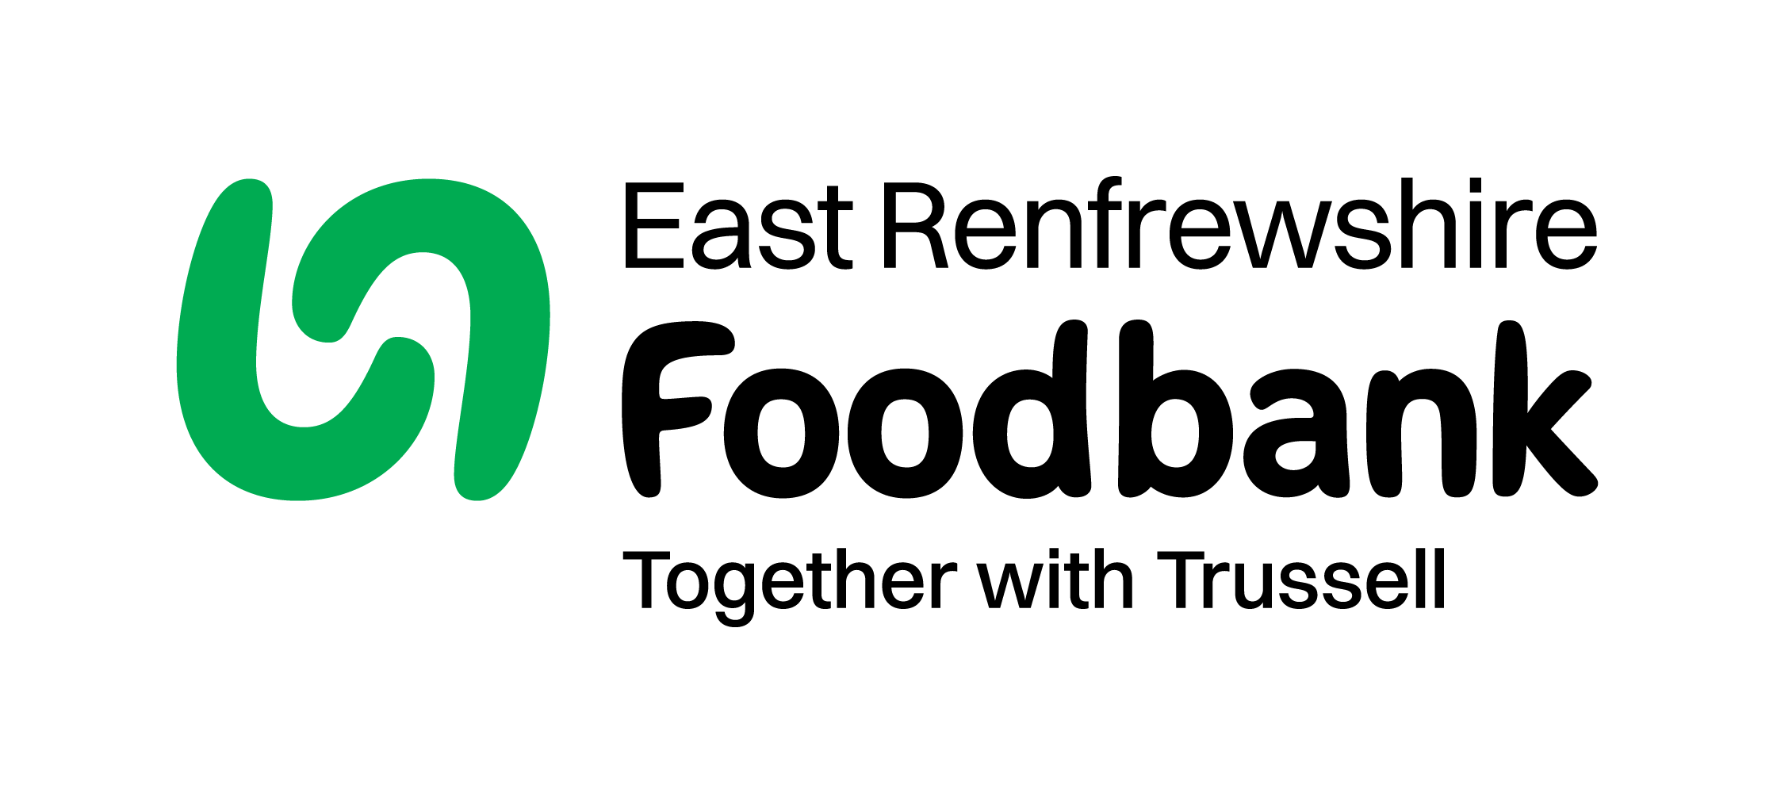
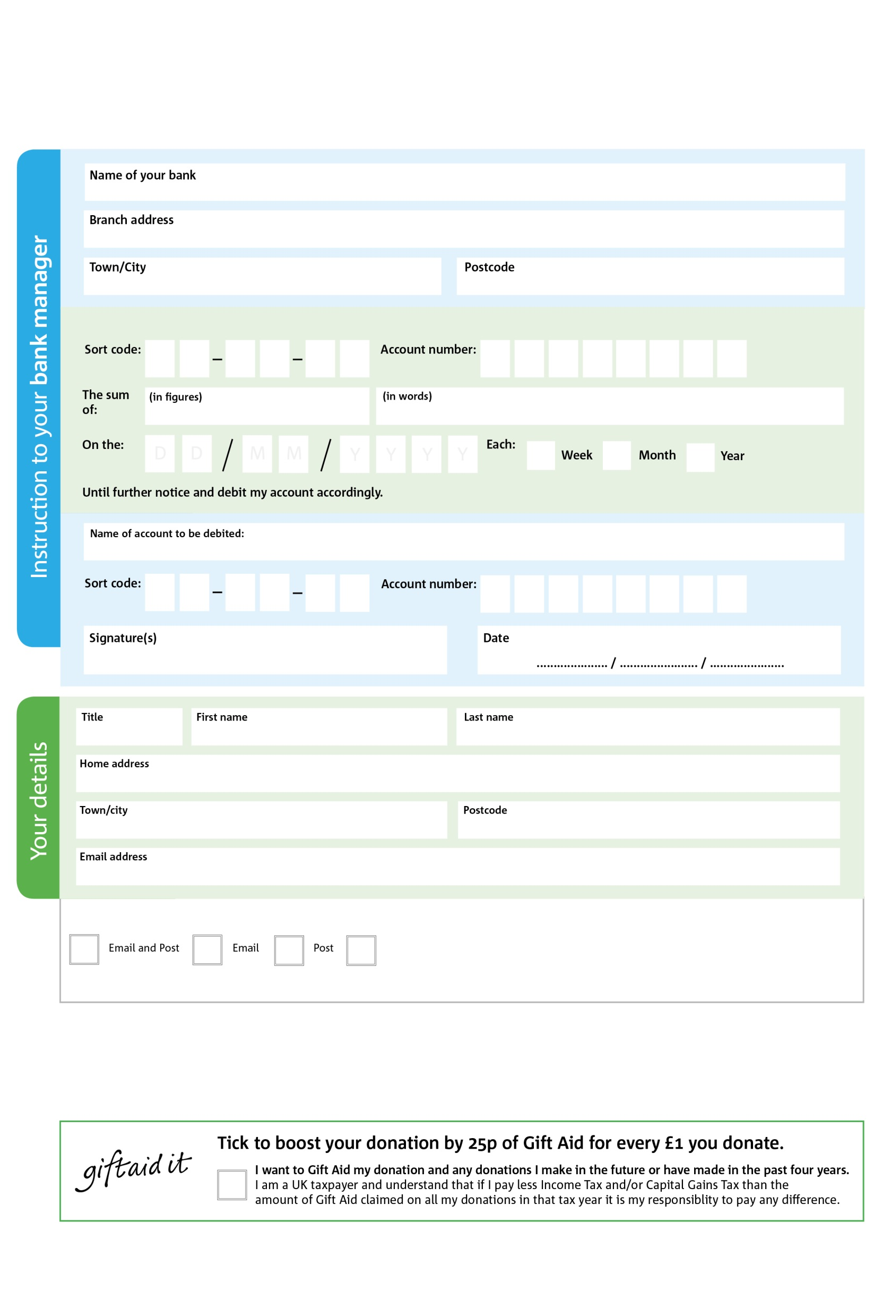
Standing Order Mandate
eastrenfrewshire.foodbank.org.uk

POSTAL ADDRESS: Bank Street Entrance, 14 Lowndes Street, Barrhead, East Renfrewshire, G78 2QX
Reg. Charity No: SC054839 | Reg. in Scotland
0

V
5

V
4

V
9

V
9

V
2

V
0

V
0

V
Please pass this form onto the foodbank, using the foodbank’s address at the bottom, who will save a copy for their records.
They will then send it onto your named bank or building society.

4

0

6

1

3

88

We would love to keep you up to date with information about East Renfrewshire Foodbank. Please tick your preference:

You can change your preferences any time by contacting us on 0141 881 8250 or emailing us at erfoodbank@gmail.com

I do not wish to receive future communications from East Renfrewshire Foodbank

Pay East Renfrewshire Foodbank Foodbank,

Data protection
East Renfrewshire Foodbank is committed to protecting your privacy and will process your personal data in accordance with current Data Protection legislation. East Renfrewshire Foodbank collects information to keep in touch with you and supply you with information relating to our work. To unsubscribe from our newsletter, send a message to the email address above with the word unsubscribe in the subject line. A full data privacy statement for financial donors is available from the foodbank on request.

You can change your preferences any time by contacting us on XXXXXXXXXXX or emailing us at XXXX@XXXXXXXXXX.foodbank.org.uk

I do not wish to receive future communications from XXXXXX Foodbank

