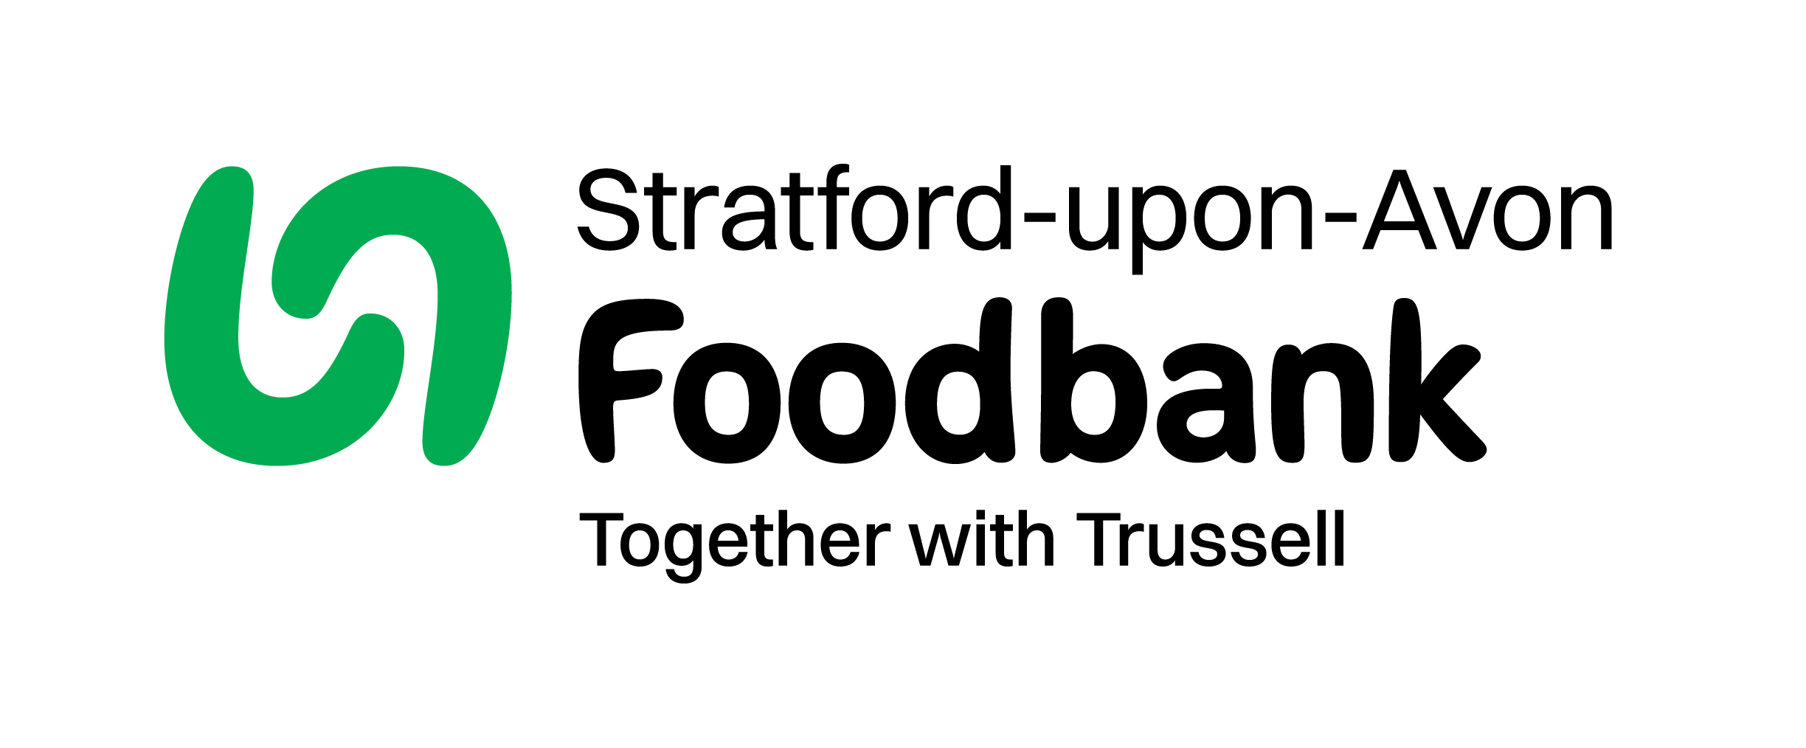
Stratford-upon-Avon Foodbank
The Fred Winter Centre
41 Guild St
Stratford-upon-Avon
CV37 6QY

chair@stratforduponavon.foodbank.org.uk

Volunteer Trustee Application Form

Thank you for your interest in applying to be a Trustee of Stratford-upon-Avon Foodbank. In order for us to process your application please answer the following questions. If you have any questions or would like help completing the application, please contact the Chair of Trustees at the above email address.
Your details:
Title:
Full Name:
Address:
Postcode:
Phone:
Email:
Date of Birth:

Next of Kin:
Name:
Tel No:
Relationship:
Contact in case of emergency: (if different)
Name:
Tel No:
Relationship

I have skills in the following areas:
Please enclose your CV with your application

Please tell us your previous work experience or qualifications:
Please enclose your CV with your application

Please state your reasons for wanting to be a Trustee:

Please enclose a covering letter with your application, outlining why you believe you could contribute as a Trustee of the Foodbank, and what you would like to get out of volunteering as a Trustee.

Please provide any information you think may be useful to us:

If successful in your application, would you be willing to sign the Trustee Eligibility Declaration?
☐ Yes
☐ No

If successful in your application, would you be willing to sign and adhere to the Code of Conduct, detailed in the enclosed role description?
☐ Yes
☐ No

Would you be willing to for us to submit for a DBS criminal record check, if required?
☐ Yes
☐ No

Do you have any criminal convictions (except those ‘spent’ under the Rehabilitation of Offenders Act 1974)? (NB: this does not necessarily prevent you from volunteering)
☐ Yes
☐ No

If yes, please give details:

Referees: Provide phone and email contacts for two people we can contact for a reference (no family members please). We will only contact them if we plan to progress with your application after the interview stage
Referee 1
Full Name:
Phone:
Email:
Relationship:

Referee 2
Full Name:
Phone:
Email:
Relationship:

Data protection: Stratford-upon-Avon foodbank will hold your details on file but will not release them to a third party.
I confirm that the above information is complete and correct. I consent to the processing of this data in the consideration of my application and during the course of my volunteering, if applicable. I also consent to the sharing of my email address amongst the team to facilitate communication.
Signature: ______________________ Date: __________________

Please return completed form via email chair@stratforduponavon.foodbank.org.uk

