
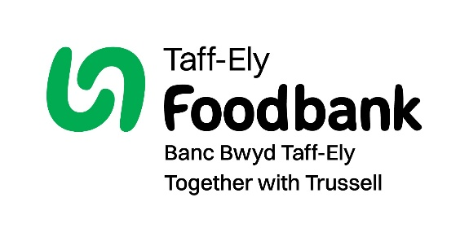
Please do not contact me via Telephone
Please do not contact me via Post
Please do not contact me via Email
To change your communication preferences at any time, please call us on 01443 520 730 (Monday to Thursday, 9am to 1pm) or email info@taffely.foodbank.org.uk.

Postcode:
Phone:
Address:
Please pass this form onto Taff-Ely food bank, using the food bank’s address at the bottom, who will save a copy for their records. They will then send it onto your named bank or building society.

taffely.foodbank.org.uk

Please pay Taff-Ely Foodbank
66
3

9

7

9
2

3
4
8

9

0

3

7

9

–
–
Account number:
Sort code:
The sum of:
(in words)
(in figures)
Name of your bank
Branch address

–
–

Account number:
Sort code:
Until further notice and debit my account accordingly.
On the:
/
/
M
M
D
D
Y
Y
Y
Y
Each:

Month
Year

Week

Name of the account to be debited:
Date:
Signature(s):
Your details
Let’s keep in touch
Name:
Title:
Email:
By filling out this Standing Order form, you are giving us permission to send you updates with information about our work, fundraising activities and ways to get involved. To want to opt-out of this, please tick the boxes below:
If you are a UK tax payer, we can reclaim 25p for every £1 you give, that is an extra 25% on top of your gift!

Date:
I want to Gift Aid my donation, and any donations
I make in the future or have made in the past four years, to Taff-Ely Foodbank.
I am a UK taxpayer and understand that if I pay less Income Tax and/or Capital Gains Tax than the amount of Gift Aid claimed on all my donations in that tax year it is my responsibility to pay any difference.

Sending in your Gift Aid form
Please send the completed form to: Taff-Ely Foodbank, Unit 3, Ely Valley Business Park, Pontyclun, RCT, CF72 9DZ

Registered charity number (1195468). Registered in England and Wales.
Data protection
Taff-Ely Foodbank is committed to protecting your privacy and will process your personal data in accordance with the General Data Protection Act 2018. Taff-Ely Foodbank collects information to keep in touch with you and supply you with information relating to our work. This includes informing you of fundraising that might be of interest to you. Taff-Ely Foodbank will never sell or pass your details to anyone who isn’t directly working on our behalf.

Instructions to your bank manager
Standing Order Mandate

